PowerBuilder Utility

PBUtility is a free PowerBuilder Application that provides some useful utility tools for PowerBuilder from version 6 to 2021. I will try to update the latest version.

**Installation**

Run putility.exe you will see it appear system tray icon. select sytem -> intergate. you will restart PB**,** you will see a new toolbar in PowerBuilder.



**Features:**

**Auto Comment : Add comment editer**

**Format Code : Powerbuilder format code**

**Upper Case : Upper select text**

**Lower Case : Lower select text**

**Add Tab : Add tab before or after using flag**

**SQL Format : SQL format select text**

**Auto Complete : Complete text from text using flag**

**Trim Code : Trim text using flag**

**DataWindow Automation: General code from datawindow**

**Objects List: Show list objects support (find , compare, show source, show duplicate)**

**Compare PBL version: Compare PBL**

**Color: Get color code**

**Option: Config options**

**Full Comment**

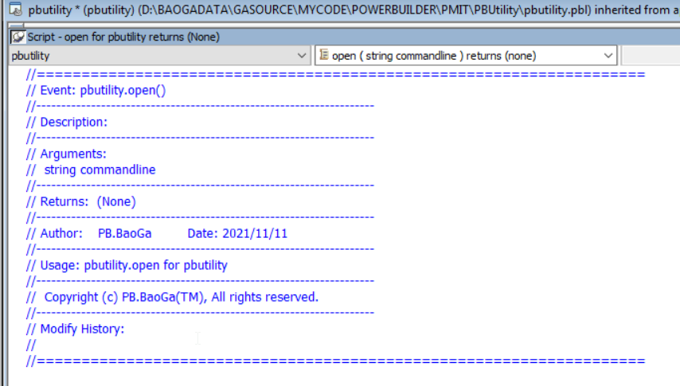

**Modify comment**

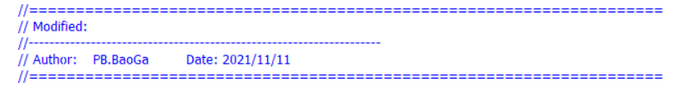

**ADD Comment (ctrl + mouse)**

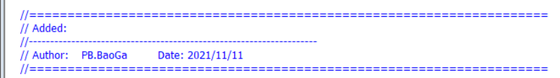

**Delete Comment (shift + mouse)**

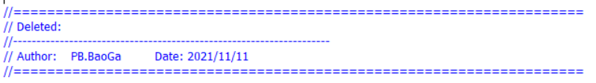

**Step Comment**



**Format Code**

**Format the code in PB script editor with the default indent rules.Note: If the active window in PB is not a editor, the operation has no effect.**

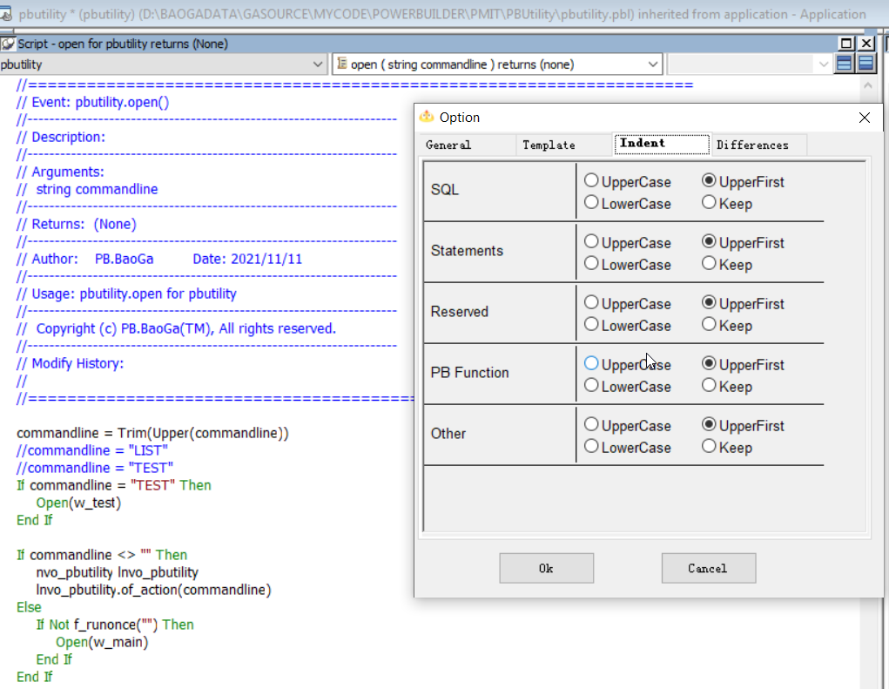

**Add Tab**

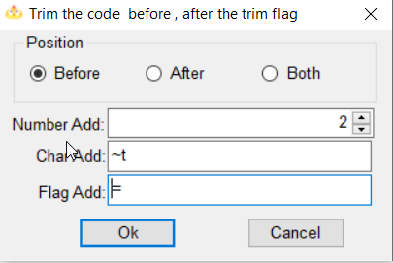

**Auto Complate**

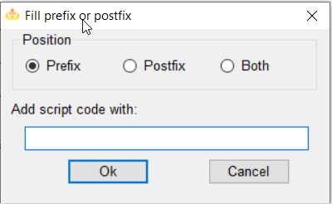

**Trim Code**

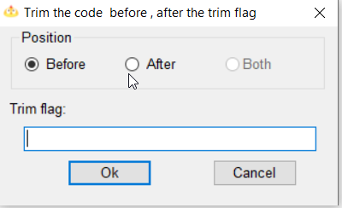

**DataWindow Automation**

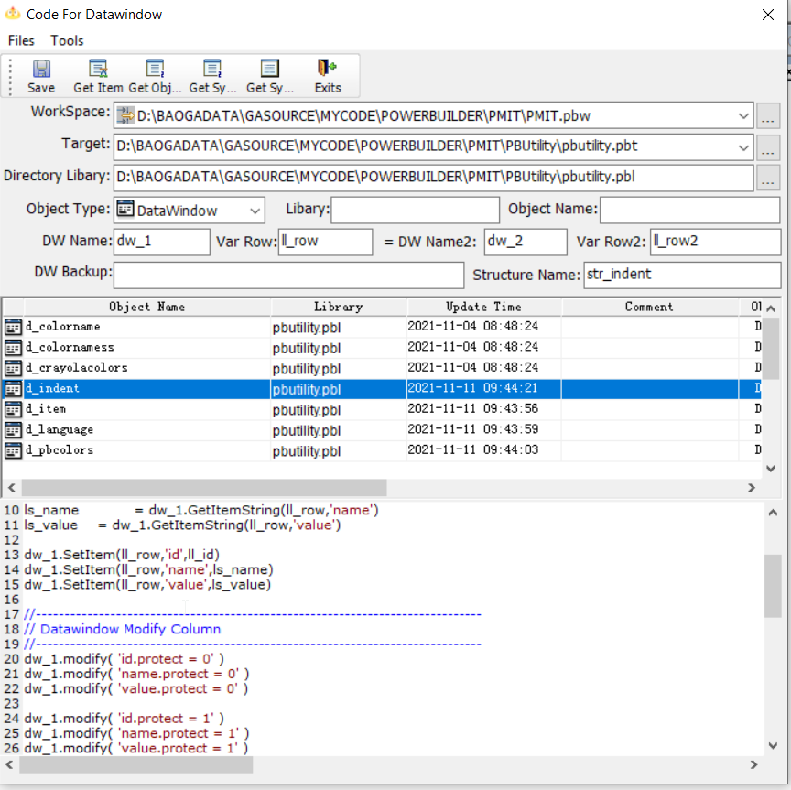

**Objects List**

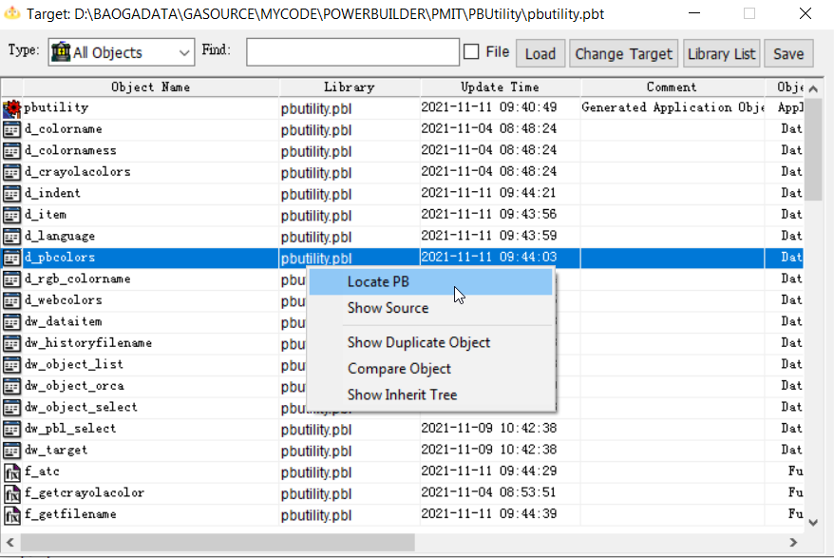

**Compare PBL version**

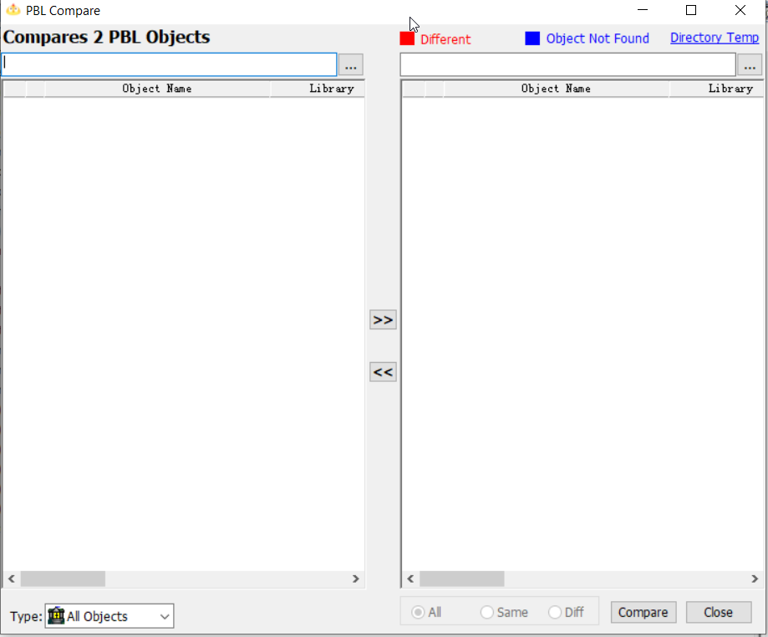

**Color**

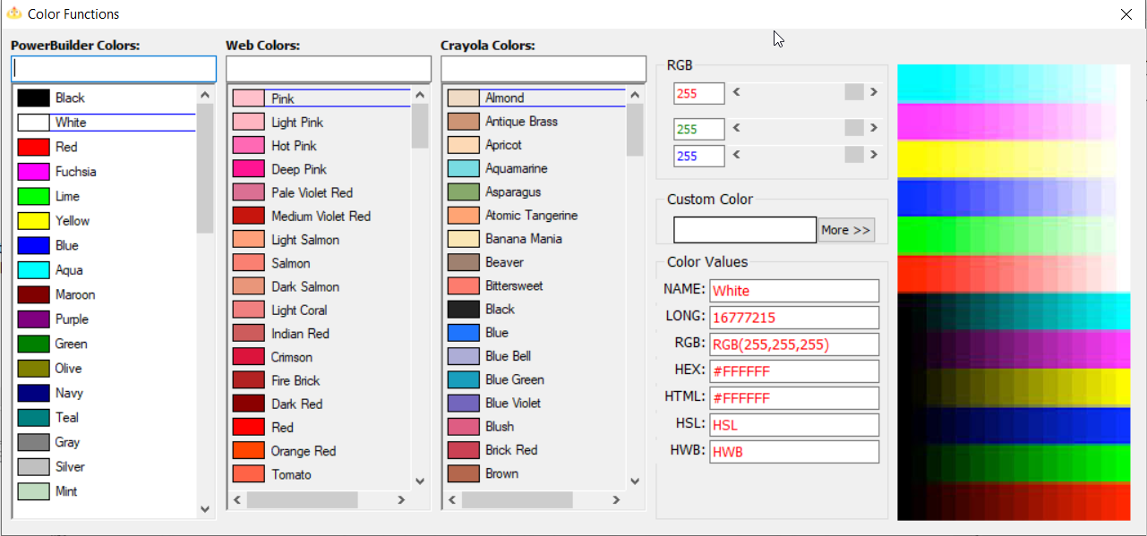

**option**

